

FS Maintain COI in the Process Order

Functional Design Specification

Document Version Number: 1.0

Page 1 of 7

Table of Contents
1
1 Table of Contents 1
1 Business Functionality Overview 2
1.1 Functional Specification Type 3
1.2 Business Functionality 3
Quality Management and Controls 3
1.3 Security Considerations 4
1.4 Business Dependencies 4
1.5 Business Criticality 4
1.6 Assumptions 4
1.7 Overall Business Flow Diagram 4
2 Enhancement 5
2.1 Process Flow Diagram 5
2.2 Enhancement Specification – COI on process order header 6
2.2.1 Trigger 6
2.2.2 Check if the process order is relevant for the CGT patient materials scenario (ZVV_PARAM) 7
2.2.3 ZCOI field in the Custom Data tab 7
2.2.4 Process order is relevant for the CGT patient material scenario but no COI is maintained: 8
2.2.5 Validate the COI via Checksum 8
2.2.6 Process order is saved successfully 8
4.2.5 Process order is released 9
2.3 Enhancement Specification – Component's batch search procedure based on COI 9
2.4 Enhancement Specification – Consumption against the process order 10
2.5 Error Handling Specifications 10
3 Related Documents 10
4 Document History 10
5 Appendix 10

Business Functionality Overview

Functional Specification Type

FS Type | Applicable
Reports
Interfaces
Enhancements | X
Forms
Workflows

Business Functionality

In autologous Cell and Gene Therapies the delivered product is always patient specific. In most of the cases cell material from a patient is taken (apheresis), modified and placed back in the patient. In some cases, instead of patient material, healthy donor material is being used.
Chain of Identity (COI) and/or Chain of Custody (COC) records, which are used in the regenerative medicine therapy manufacturing process for traceability and to ensure product safety and quality. Chain of Identity (COI) refers to the end-to-end traceability of a drug right from raw materials sourcing (which in the case of autologous cell therapies refers to the patient) to preparatory steps leading to manufacturing and finally delivery and infusion. For autologous cell therapies, Chain of Identity (COI) and Chain of Custody (COC) are critical for safety, quality and to ensure the right patient is matched with the right donor cell to the right product.

For Cell and Gene Technologies, for the Patient / Donor material process it is necessary to maintain the COI (Chain of Identity) as a tracking number at process order level, from the moment of process order creation (cor1 or by converting a planned order).

The Chain of Identity number should display in COR2/COR3, be copied into the FERT batch characteristics when the batch is created and will be used for batch determination.

The Chain of Identity number is therefore mandatory for Patient Material. We define if a FERT is patient material or not based on material classification (check on save and display error message).

From the URS document the following items are deemed as relevant for this FS:

“Process Order and Manufacturing
Create a Process Order (PrO) with finished product and COI will be maintained in custom field in the custom data tab.
Batch number is assigned at the time of process order creation via user-exit “EXIT_SAPLV01Z_002 – Batch Number Creation” in the format yyssjjjxxx.
For co-products the batch number is assigned at the moment of creation of the process order as the information should be available prior to the GR of the FDP.
After release of the Process Order, the received patient materials (CSTM) material can be assigned to the process order via the custom batch determination process based on the COI. Only materials may be assigned if the COI matches. The COI cannot be added/changed after release.
At the time of goods receipt of FERT material, quantity will be distributed according to bag volume and separate batches will be created for each individual bag.
Process Order data can be transferred to MODA via interface.

Quality Management and Controls
Batch must be in unrestricted inventory with a COI that is equal to the COI of the process order batch.
When process order is released, execute a custom batch determination rule to determine the Patient Material batch to be used on the Process Order.
When the Post Goods Issue (PGI) of the Patient Material is posted against the process order, run a custom validation to ensure that the COI matches.”

Security Considerations

Access to transaction codes is restricted by user roles.
ERES is not applicable (e-signature is not used for changes; changes are not tracked in a change log).
Changes of a process order are only possible according to the process order status (i.e., it is only possible to modify a process order before it is released).

Business Dependencies

The creation of the process order is fairly a manual task but conversion from a planned order is possible. The COI should be scanned at process order creation from the Biospecimen form whenever possible to minimize the chances of entering a wrong COI.

Business Criticality

- In case the COI is not maintained for a process order to produce a patient material: The batch determination rules will not take into consideration the COI and therefore the production of patient material will be compromised as it is not possible to ensure that the correct donor material is being used for the product to the correct patient.

- In case the COI is maintained for a non-patient material order: The COI might be incorrectly assigned to the process order and that will be copied into the batch master characteristics of the header material. The COI report will show incorrect information.

Assumptions

It is assumed that the COI will be maintained manually at process order creation and that the user will enter a correct and valid COI. The COI can be entered by scanning (not mandatory).

Overall Business Flow Diagram

Enhancement

Process Flow Diagram
If the process order is relevant for the CGT patient materials scenario, the custom field (ZCOI) is displayed and it is mandatory. The process order id determined as being CGT patient materials relevant based on customization in ZVV_PARAM table.

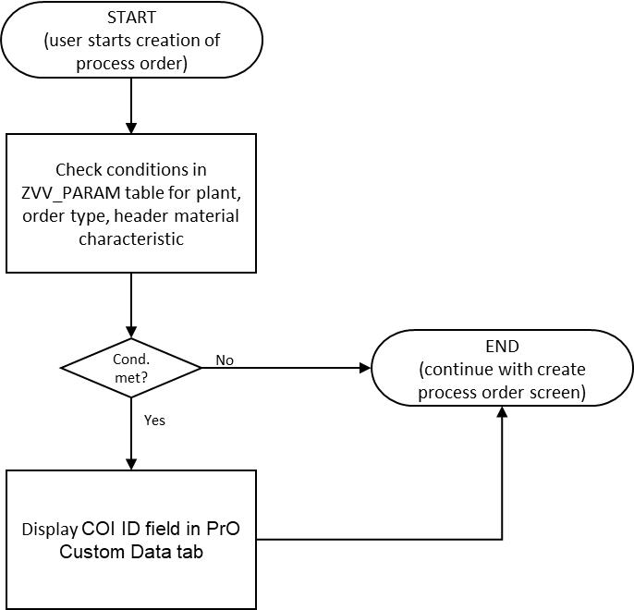

On saving a process order, a check is done to ensure COI has been maintained for the CGT patient material scenario before release:

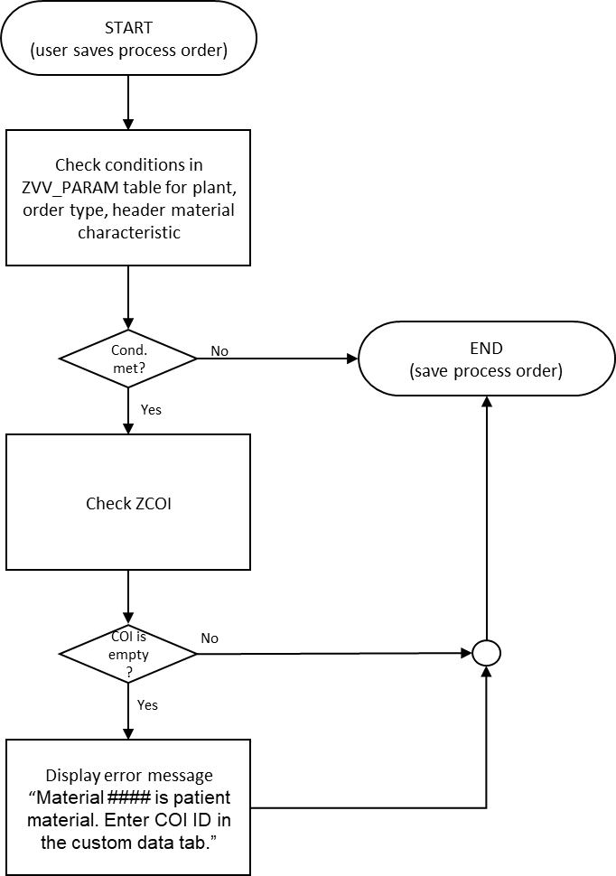
It is allowed to save the process order without COI before release. In that case only warning is displayed.

Enhancement Specification – COI on process order header

Trigger

The enhancement should be triggered
- When the user accesses COR1/COR2/COR3 (also via COR7).
- When the user initiates saving of the process order.

The check on saving process orders will also be applicable for mass creation of process orders. It will not be possible to enter a COI on collective conversion of planned orders and therefore COR8 will not be used in this scenario. An error will be displayed preventing saving without COI.

The following fields are relevant and need to be retrieved to perform the check:

Field Name | Data element | Retrieving logic
Material number | CO_MATNR | Entered by user on selection screen
Production Plant | WERKS_D | Entered by user on selection screen or determined by the system on ENTER
Proces order type | PI_AUFART | Entered by user on selection screen or determined by the system on ENTER
Characteristic value for “Hazardous class” | ATWRT | For CO_MATNR, RCTAV-ATNAM=NL_HAZARDOUS_CLASS

Check if the process order is relevant for the CGT patient materials scenario (ZVV_PARAM)

The conditions for this enhancement are maintained in the ZVV_PARAM parameter table (Tcode ZVV_PARAM) with a new Lookup-Name (ZCOI_PrO).

The process order is relevant for the scenario and the enhancement is triggered if conditions 1 and 2 and 3 are met:
- Production plant is NL08 or USH1
- Process order type is PI01 or PI20 (can also be blank)
- Characteristic value for “Hazardous class” is 08 (for best performance, retrieve and check only when conditions 1 and 2 are met)

These conditions are maintained in the ZVV_PARAM table as below:

Lookup-Name (LOOKUP_NAME) | Freely Def. Key (FREE_KEY) | Free key Value (FREE_KEY_VALUE) | Indicator (INDICATOR1) | Value 1 (ZVV_PARAM- VALUE1)
ZCOI_PrO | WERKS_D | 001 | x | NL08
ZCOI_PrO | WERKS_D | 002 | x | USH1
ZCOI_PrO | PI_AUFART | 001 | x | PI01
ZCOI_PrO | PI_AUFART | 002 | x | PI20
ZCOI_PrO | ATWRT | NL_HAZARDOUS_CLASS | x | 08

The program must be able to consider entering additional entries in the parameter table.

ZCOI field in the Custom Data tab

The COI number will be stored in the process order header table.

Database Field | Field name | Field description | Format | length
AFKO-ZCOI | ZCOI | Chain of identity ID | CHAR | 30

If the process order is determined as being CGT Patient material relevant, the field is displayed in the process order Custom Data tab:

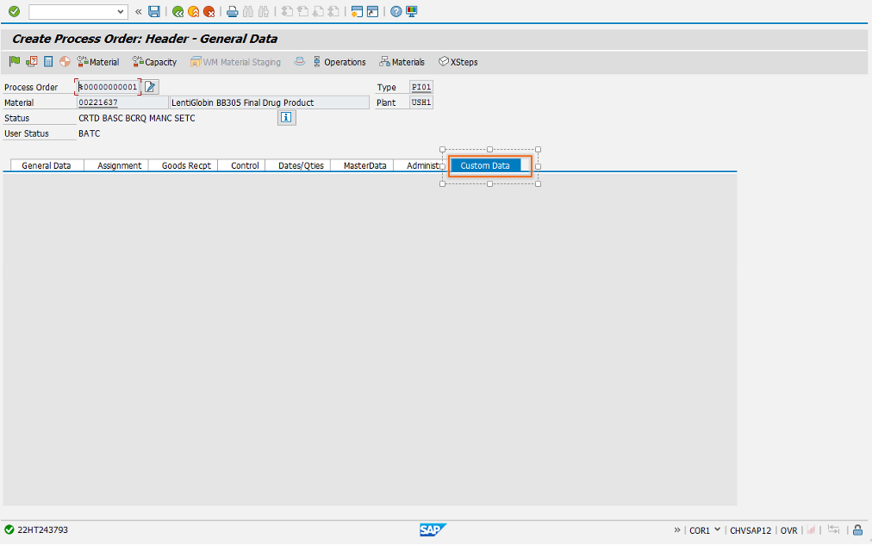

Process order is relevant for the CGT patient material scenario but no COI is maintained:

If ZCOI is blank, display warning message “Material #### is patient material. Enter a COI ID in the custom data tab.” On release the warning message becomes an error message (see below).

Validate the COI via Checksum

When the user populates or changes the COI, the checksum is performed and the calculation result, two digits, is displayed (information) to the user via pop-up, so that the user can validate the entered COI:

“Checksum for COI <#####> is <XXX>. Do you confirm this value?”
Options “Confirm” and “Correct” should be given.
If the user selects “Correct”, the COI field is made blank again.

For details on the COI checksum calculation refer for the 3way-check Functional Specification.

If the checksum resulted in error, display the message (error):

“Checksum for COI <#####> could not be calculated. Do you wish to continue?”
Options “Continue” and “Cancel” should be given.
If the user selects “Cancel”, the COI field is made blank again.

Process order is saved successfully

When the process order is saved successfully:
- The FERT Batch number was created in the format yyssjjjxxx and assigned to the process order via user-exit “EXIT_SAPLV01Z_002 – Batch Number Creation” (already implemented). This enhancement is modified to also create batches for any co-products in the BOM, with the same material as the process order header material.
- Once the order is saved, the batch records are created.
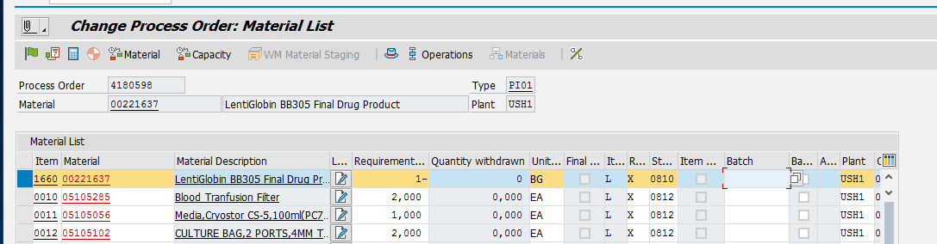
- COI is copied from the process order into the batch class 023 PRODZUST, characteristic COI.
- The creation of the process order and the Batches triggers the following interfaces sending info to MODA-ES:
  - LOIPRO
  - BATMAS
  - MATMAS

The details of the changes to the interfaces are covered under a separate FS.

4.2.5 Process order is released

On save, also after release, the same check to see if COI is filled is done and the same error message is displayed if required.

Enhancement Specification – Consumption against the process order

Trigger: process order identified as patient specific relevant, i.e., AFKO-ZCOI not blank.

During goods issue/goods receipt against that process order, check that for the patient material components or header material or co-products with the same material (material type CSTM/FERT, Characteristic value for “Hazardous class” is 08), the ZQM_ZCOI-ZCOI is equal to AFKO-ZCOI. If not, display an error message: “Batch #### COI ID is different from the order COI ID.”

Error Handling Specifications

Possible errors that might occur:
- Process order type is not entered/determined for order creation -> Continue the check without considering order type
- Material master needs to be correctly maintained to have 023 PRODZUST (validate that PRODZUST is there).

Related Documents

Documents Name | Description
GROUP-117818 | URS SAP ERP Project Alpha Patient Material Chain of identity
GROUP-600 | XS SAP ERP PR Production
GROUP-117815 | DS SAP PO MES Interfaces
GROUP-107946 | DS SAP ERP MES Global Interface Mapping

Document History

Ver # | Date | Author | Brief Description of change
1.0 | 30-Aug-2022 | Ana Severiano | Initial version

Appendix
N/A.

